LAB TEST 1

1answer:

* Task: Task: Write two different prompts to get a summarized news report from an AI model.
  + One with poor context.
  + One with detailed context (e.g., specify tone, target audience, and summary length).
* Compare the outputs and explain which is more effective and why.

1. Prompt:give me a summarized news report from an AI model

Code:

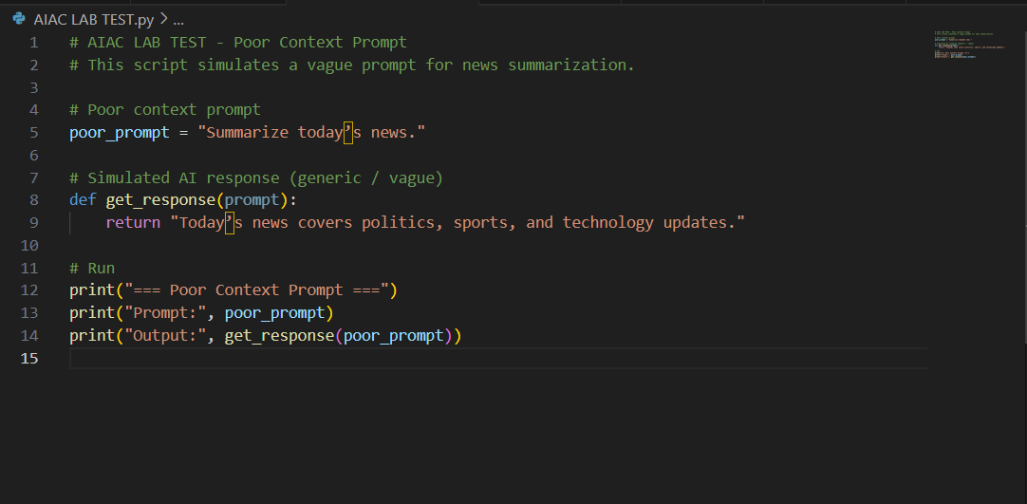

Output: 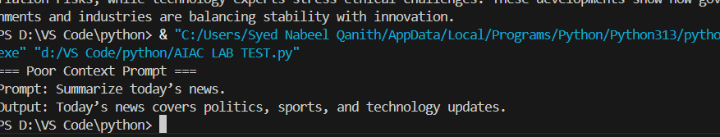

b)prompt:give me a summarized news report from an Ai model with dertailed context of specify tone,target audience,and summary length.

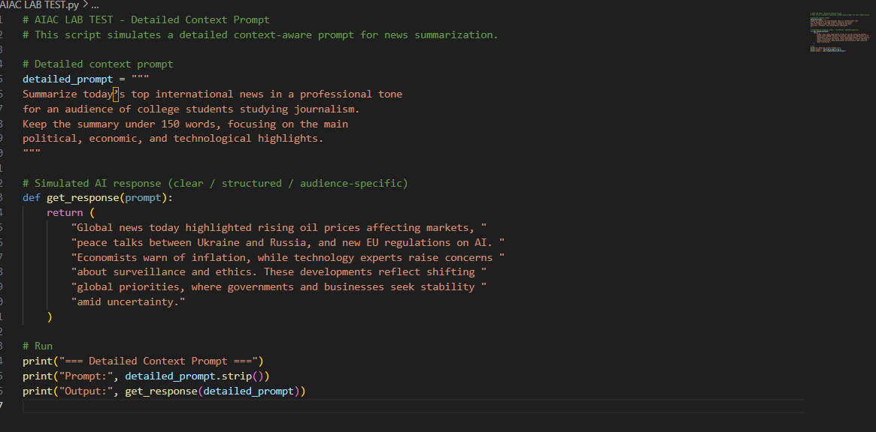

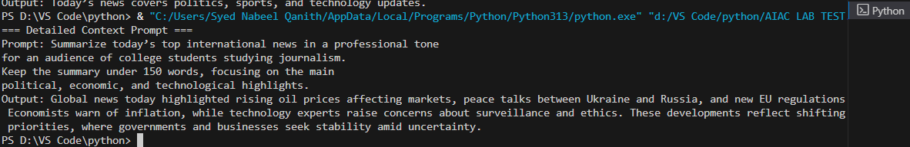

Observation: poor **Context Prompt:** Leads to a vague, surface-level answer without structure or clarity. The AI doesn’t know what style, audience, or scope to follow.

**Detailed Context Prompt:** Produces a **clear, relevant, and structured summary** tailored to the audience (journalism students) with appropriate tone and length.

2) TASK: **Q2. Multi-Turn Prompting Design [5 M]**

* Scenario: You are designing a chatbot for customer support.
* Task: Write a sequence of **3 prompts** where each uses the **previous response as context** (conversation continuity).
* Evaluate how context improves the AI’s accuracy.

Prompt1: I ordered a laptop last week but it hasn’t arrived yet. Can you help me check the status?"

Code:

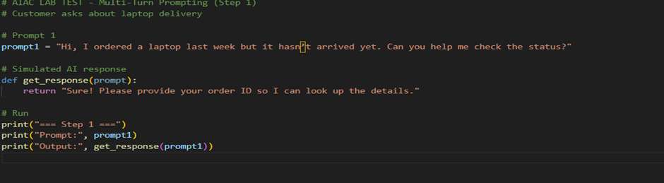

Output:



Prompt2: Yes, the order ID is #LAP12345."

Code:

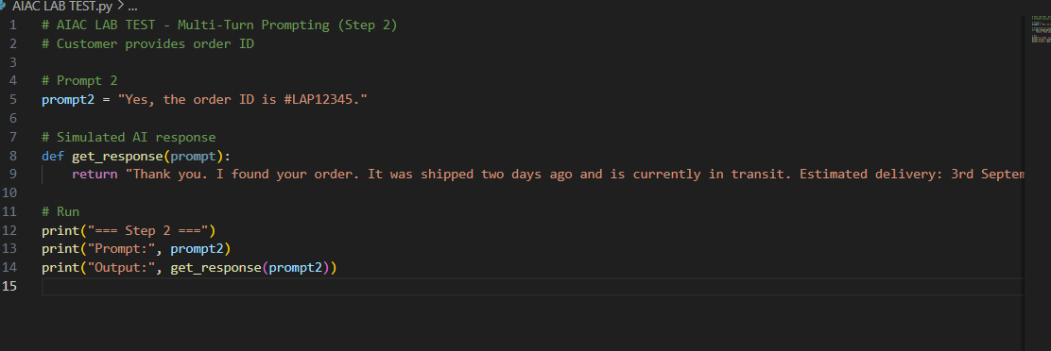

Output:

Prompt 3: "Great, can you also tell me the courier service and tracking number?"

Code: 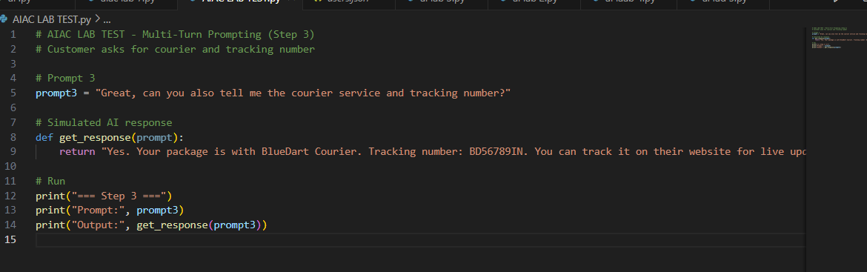

Output:

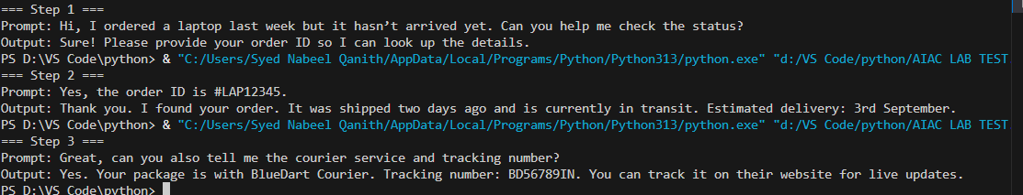

Observation:

**Evaluation – How Context Helps**

* **Without context:** If the chatbot didn’t remember earlier turns, it wouldn’t know the order ID or that the user asked about delivery. Each message would restart from zero, leading to confusion.
* **With context:** The chatbot **retains conversation history**, so it accurately gives delivery updates and tracking info without asking the same questions repeatedly. **Conclusion:** Multi-turn context improves the chatbot’s accuracy, efficiency, and user experience by making the conversation **continuous and natural**.